
Aspirevision Tech Education Pvt. Ltd.

Project Documentation for:
Airline reservations system

Submitted by:

PRANJAL CHOWDHURY
PARTHO PROTIM SARKAR
Bidisha Biswas
Arup Mathura

Under Guidance Of:

Md. Farmanul Haque

Acknowledgement:

I am very happy to compile this project, along with my talented group members.
However, it would not have been possible without aid from multiple individuals.

I am highly indebted to AspireVision Tech for training me and providing me with all the necessary knowledge.
I would like to express my gratitude to Md. Farmanul Haque, whose advice and guidance has proven invaluable in bringing about the end product. It is through his constant encouragement that I have been able to see this project to its completion.
There was also a lot of support throughout the course of the project from Mr. Brijesh Kumar who oversaw the entire process and extended his aid whenever required.

I also have immense appreciation for my group members for their constant cooperation and help.

ABSTRACT

The objective of the project is to design an Airline Reservation System application which enables the customers to search and book flights, packages and hotels. The project has been designed in Django python technology and consists of a SQL server which acts as the database for the project.

My motivation for the project came from my enthusiasm and strong urge to learn PYTHON and DJANGO which is one of the fastest growing technologies in today’s world. The Airline Reservation System project mainly consists of two types of users. The customers who access the information provided by the website and the administrator who modifies and updates the information available in the website. All the data needed for the application is stored in the form of tables in the SQL server 2000.

The report contains the details of all the tasks carried out during the entire software development life cycle of the Airline Reservation Project. This document depicts all the details of the project starting from the project design to testing.

Table of Contents

CHAPTER 1 - VISION DOCUMENT

- INTRODUCTION
- OVERALL PRODUCT DESCRIPTION
- SPECIFIC REQUIREMENTS
- FUNCTIONAL REQUIREMENTS
- PERFORMANCE REQUIREMENTS

CHAPTER 2- ARCHITECTURE DESIGN

- INTRODUCTION
- ARCHITECTURE OF THE AIRLINE RESERVATION SYSTEM
- PRESENTATION TIER
- BUSINESS LOGIC TIER
- DATABASE TIER

CHAPTER 3 - COMPONENT DESIGN

- INTRODUCTION AND PURPOSE
- CLASS DIAGRAM

CHAPTER 1 - VISION DOCUMENT

1. INTRODUCTION

1.1 PURPOSE AND MOTIVATION

The main purpose of this vision document is to list the requirements of the Airline Reservation System project. This document also helps us to collect and analyze the ideas gathered for the project. This vision document will be subject to change, if more requirements are added to the project. This document is mainly prepared to set stage for the design phase of the project. The document being prepared is the first version of vision document for the Airline Reservation System project.

Django is a new technology which is being used a lot in the IT field. My interest to learn this new technology has prompted me to take up this project, which would set the stage for the applications I would be developing in the future.

1.2 PROJECT OVERVIEW

The Airline Reservation System project is an implementation of a general Airline Ticketing website like Orbitz, which helps the customers to search the availability and prices of various airline tickets, along with the different packages available with the reservations. This project also covers various features like online registration of the users, modifying the details of the website by the management staff or administrator of the website, by adding, deleting or modifying the customer details, flights or packages information. In general, this website would be designed to perform like any other airline ticketing website available online.

.

- OVERALL PRODUCT DESCRIPTION

2.1 PRODUCT PERSPECTIVE

The Airline Reservation System project uses the .NET framework 1.1 and is completely independent. The project itself is a bigger product and does not need to be introduced into a larger system. The application would be running on a Windows XP/2000 Operating system

2.2 PRODUCT FEATURES

The Airline Reservation System has the following features:

This project is mainly intended for two types of audiences. One is the customer or the end user and the other is the administrator of the website. Some of the major functions of the product can be categorized under two different categories that are for the administrator and the user.

2.2.1 Customer / End user activities













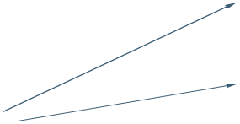
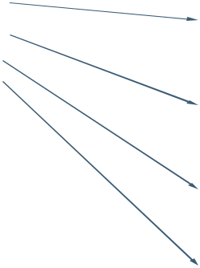




Figure 1 - Customer use case diagram

The above use case diagram depicts all the functions or activities that a user or a customer can perform on the application. They can be discussed in detail as follows:

Home Page: Like all the other airline websites available online, the user can access the user home page of the Airline Reservation System website, after he logs into the system.Here, he can look up information regarding flights, packages and motels.

Login and Register: The Airline Reservation System also comes with the customer registration details page, where the customer can enter his details and register. He can also create a username and password. Moreover, he will also be able to modify the registration information in case of a change in his e-mail address or any other information.

Booking Flights: The customer can also search for the flights available and reserve his place on the flight by purchasing a ticket.

Book Motels: Different Airline websites like Orbitz also offer various deals for booking Motels along with the airline tickets. So, the customer will also be able to view this functionality on the website.

Book Packages: This functionality is similar to the motel booking function, except the fact that the customer can look up various touring packages available at the person’s destination.

Contact the Company: The Customer can also call the company if he has any concerns or questions related to the bookings he has made online.

Booking Instructions: The website also provides instructions to the customers on how to book airline tickets or motels along with the different packages.

Some of the functions of the Airline Reservation System, such as creating, maintaining and updating the database are available only to the administrator. The functions of the administrator, explained in detail are as follows:

2.2.2 Administrator Activities

Login/Logout: The administrator has to login first in order to be able to make changes to the Airline Reservation System, by adding, deleting or modifying the data in the Airline Reservation System database. After making the necessary changes, he then has to logout of the system, in order to prevent misuse of the data.

Add/Modify Customer Information: Daily the Airline Reservation System will have many customers registering with the website and many of them unsubscribing. Only the administrator will have the sole rights to modify the database accordingly.

Add/Modify Flight Information: The Administrator also has the sole rights to add, delete or modify the flight information. Sometimes, flights get cancelled for some reason, so such flights would be removed from the list of flights available to the customer. Similarly whenever any flight information has to be modified or if any new flights need to be added to the database, these operations are performed by the administrator.

Add/ Modify Motel Information: The administrator can also add/delete or modify information related to different motels. This information can be the number of rooms available at the motel, the prices etc.

Cancellation of Reservations: Sometimes, after making a reservation, a customer might cancel the reservation he has made. So, the administrator also handles such special situations and sends the customer an e-mail confirmation after deleting the specific transaction.

E-mail confirmations: Whenever a customer makes or cancels a reservation, the administrator is responsible for sending confirmation e-mails to the customer, confirming the transaction.

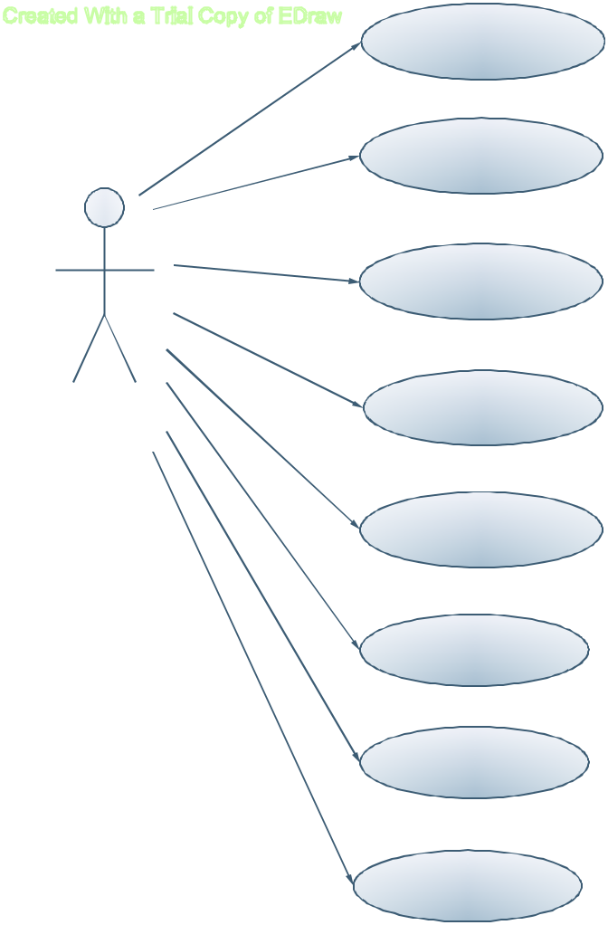
Login/Logout

Add/Delete/Modify

Customer Information

Add/Delete/Modify

flight information

Add/Delete/Modify
Administrator Motel information

Add/Delete/Modify

Package Information

Cancellation of

Reservations

Modify details of

webpage

E-mail

confirmations

Figure 2 - administrator use case diagram

2.3 USER CHARACTERISTICS

There are two kinds of users for the Airline Reservation System. One is the customer and the other is the administrator. The customers do not need to have any prior training to use the application. However, instructions for making flight and motel reservations would be provided to them on the airline website. The administrators would however need to be trained in order to use the application.

2.4 CONSTRAINTS

Incase of changes made to the database, the application should be able to show the updated information on the website, without much delay. The database for the project is designed to be of moderate size. Currently, the application is designed to be able to run in Internet

Explorer. The Airline Reservation system will be designed in such a way that, it can be run on a Windows XP/2000 and IIS server. The .NET technology will be used to code the project and SQL server 2000 will act as the database for the project. The project will run on Internet Explorer and it should be installed on User’s system.

2.5 ASSUMPTIONS AND DEPENDENCIES

There are no assumptions as of now. To be updated in later versions of the vision document.

3. SPECIFIC REQUIREMENTS

3.1 EXTERNAL INTERFACES

The different types of interfaces that we would come across while developing the Airline Reservation System application are as follows:

- User Interface

- Hardware Interface

- Software Interface

3.1.1 USER INTERFACE

There are two types of users for the Airline Reservation System project. One is the customer and the other is the administrator. Both the customer and administrator user interface would be a graphical user interface. The graphical user interface for the customer home page would be as follows:

IMAGE

 | About usAdminPage |  | How to bookContact Us |  |  |  | Home
 |  |  |  | Email ID
 | Images |  |  | Password
 |  |  |  | L |  |  | New

Figure representing the sample Customer GUI

The Graphical User Interface would mainly consist of Hyperlinks, Data entry fields like the E-mail Id field, push down buttons like the Login button etc.

The administrator of the website would also have a similar Graphical User Interface. After an administrator logs onto the system, the home page for the administrator would be as follows:

Figure representing the sample Administrator Interface

IMAGE

Customerdetails Flight details Hoteldetails Packagedetails Cancellations

3.1.2 HARDWARE INTERFACE

The Airline Reservation System does not use any hardware interface

3.1.3 SOFTWARE INTERFACE

The application should run on a Windows XP/2000 Operating System. Since the application needs a database to store all the customer details, airline, motel and package information, SQL server 2000 would be used.

Visual Studio.NET 2003 would be used for creating the application. All the coding will be done in C#.

4. FUNCTIONAL REQUIREMENTS

The functional requirements of the Airline Reservation System are divided among the customer and the administrator of the application.

These functional requirements can be explained in detail as follows:

4.1 Use Case name: User Registration

- Description: This use case describes the scenario where the user registers with the application by providing all the necessary details, in order to make reservations or bookings for flights, motels, special packages.

- Actor: User or the Customer

- Input: The user or the customer will have to provide all the necessary details present in the customer registration form of the application.

- Output: All the details entered in the customer registration page will be verified and accepted by the system into the database.

4.2 Use Case name: User Login

- Description: This use case describes the scenario where the user logs into the application, with the username and password he has provided while registering with the system.

- Actor: User or the Customer

- Input: The user or the customer creates a username and password at the time of registering with the system. He then uses them to logon to the system and make reservations or view any information.

- Output: The application then verifies the authenticity of the username and password that the customer has provided and allows the user to view the information available on the system, if the username and password are valid.

4.3 Use Case name: Contact the company

- Description: This use case describes the scenario where the user contacts the company for any information.

- Actor: User or the Customer

- Input: The customer can contact the airline company, requesting them for any information he needs.

- Output: The application verifies the authenticity of the username and password that the customer has provided and allows the user to view the contact information for the company.

4.4 User Case name: Booking Instructions

- Description: This use case describes the scenario where the user views the instructions for booking flights, packages, or motels.

- Actor: User or the Customer

- Input: After the customer logs onto the application with his username and password, he can look up the instructions posted on the website for booking flights, packages or motels.

- Output: The application verifies the authenticity of the username and password and displays the how to book instructions page.

4.5 Use Case name: Book Flights

- Description: This use case describes the scenario where the user books airline tickets.

- Actor: User or the Customer

- Input: After logging into the application, the customer looks up the information related to various airlines and checks the availability of seats on flights. If he finds that there are any available tickets, he then purchases them.

- Output: The application verifies the authenticity of the username and password and then displays information related to various flights to the customer.

4.6 Use Case name: Book Motel

- Description: This use case describes the scenario where the user books motels at the time of airline ticket reservation

- Actor: Customer or the user

- Input: After logging onto the application, the customer looks up the information for all the available motels at his destination.

- Output: The application verifies the authenticity of the username and password and then displays information pertaining to various motels at the customer’s destination.

4.7 Use Case name: Booking Packages

- Description: This use case describes the scenario where the user books different touring packages at the airline ticket reservation

- Actor: Customer or the user

- Input: The customer looks up information regarding various touring packages available at his destination at the time of airline ticket reservation.

- Output: The application verifies the authenticity of the username and password of the customer and then displays information of various touring packages available at customer’s choice of place.

The administrator activities use cases will be described here:

4.8 Use Case name: Login/Logout

- Description: This use case describes the scenario where the administrator of the application, logs into the system and logs out after the work is done.

- Actor: Administrator

- Input: The administrator of the website logs into the application with the username and password provided to him.

- Output: The application verifies the authenticity and displays the home page of the administrator.

4.9 Use Case name: Add/Delete or Modify Customer information

- Description: This use case describes the scenario where the administrator adds, deletes or modifies customer information in the system database

- Actor: Administrator

- Input: The administrator of the applications logs onto the system with his username and password.

- Output: The application authenticates the administrator, and then displays the page where the administrator can add new customers to the database, or delete existing customers or modify details of customers in the database.

4.10 Use Case name: Add/Delete or Modify flight information

- Description: This use case describes the scenario where the administrator adds, deletes or modifies flight information in the application database

- Actor: Administrator

- Input: The administrator logs onto the system with the username and password provided to him.

- Output: The application authenticates the administrator, by verifying the username and password. Then the application displays the page where the administrator can add new flights to the database, delete the flights that have been cancelled or modify information for the flights.

4.11 Use Case name: Cancellation of Reservations

- Description: This use case describes the scenario where the administrator handles the cancellation of reservations by the customers.

- Actor: Administrator

- Input: The administrator logs onto the system with the given username and password.

- Output: The application authenticates the administrator and then displays the page where the administrator looks up the id of the customer who has requested cancellation of reservation. After canceling the reservation, the administrator then sends a confirmation e-mail to the customer.

4.12 Use Case name: E-mail confirmations

- Description: This use case describes the scenario where the administrator sends e-mail confirmations to the customers of the application.

- Actor: Administrator

- Input: The administrator logs onto the application with the username and password provided.

- Output: The application then authenticates the administrator and displays the page where the administrator can send e-mail confirmations to the customer. These e-mail

confirmations may be sent in cases where the customer has cancelled a reservation or changed the personal information available on the website.

4.13 Use Case name: Modifying details of webpage

- Description: This use case describes the scenario where the administrator logs onto the application to modify the details of the airline website

- Actor: Administrator

- Input: The administrator logs onto the application with the username and password provided to him

- Output: After verifying the username and password of the administrator, the application then allows the administrator to login. The administrators can then browse through the website and change the details of any webpage in the Airline Reservation system application.

4.14 Use Case name: Add/Delete or Modify Motel information

- Description: This use case describes the scenario where the administrator adds, deletes or modifies motel information in the database.

- Actor: Administrator

- Input: The administrator logs onto the system with the username and password provided to him.

- Output: The application authenticates the administrator, by verifying the username and password. Then the application displays the page where the administrator can add new motels to the database, delete a specific motel from the list of motels, since there are no more available rooms there. He can even update the price per room of each motel. To make it easier, the administrator might assign a unique id for each hotel.

4.15 Use Case name: Add/Delete or Modify package information

- Description: This use case describes the scenario where the administrator adds, deletes or modifies package information in the application database

- Actor: Administrator

  - Input: The administrator logs onto the system with the username and password provided to him.

  - Output: The application authenticates the administrator, by verifying the username and password. Then the application displays the page where the administrator can add new packages to the database, delete the packages that are no longer available or modify information for any particular package.

- PERFORMANCE REQUIREMENTS

The Airline Reservation System application should be able to respond to the queries submitted by the customer without much delay. When a user searches for a flight leaving from a particular place to another place, the application should not take much time to return the results, similarly for the motel and package information. Considering that the application is of moderate size, it should be able to display 10 results at a time on each page, when the customer looks up for any particular data. Since the Airline Reservation websites have much traffic, the user should also be able to logon to the system using high speed internet. Most of the requests sent to the application should be answered in less than 5 seconds.

CHAPTER 2- ARCHITECTURE DESIGN

1. INTRODUCTION

The main purpose of the Architecture Design document is to discuss the architectural design for the Online Reservation System project in a clear and concise form. This design document will give a detailed description of the presentation tier, the middle tier which consists of the class diagrams, sequence diagrams for the Airline Reservation System and finally the data tier. The Unified Modeling Language (UML) is a standardized visual specification language for object modeling. Thus, the class diagrams and the sequence diagrams depicted in the Architecture design document will be developed according to the UML standard notation.

2. ARCHITECTURE OF THE AIRLINE RESERVATION SYSTEM

The architecture of the Airline Reservation System is based on the three-tier architecture.

This three-tier architecture mainly consists of three layers namely:

- Presentation Tier

- Business Tier

- Data Access Tier

The Presentation Tier converts and displays information into a human legible form. This tier displays information related to services such as browsing the Airline website, purchasing tickets etc. It communicates with the other tiers by outputting results to the browser/client tier and all the other tiers. The Business Logic tier is mainly responsible for information exchange between the user interface and the database of the project. The final layer of the three tiered architecture is the Data Access tier, which mainly consists of the Database servers. The information related to the Airline Reservation System is stored and retrieved from here.

A simple representation of the three-tier architecture would be as follows:

Figure 4 - Three Tier Architecture
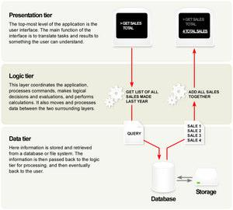

The architecture of the Airline Reservation System can be depicted as follows:

Presentation Tier
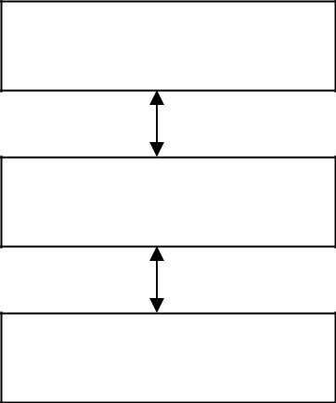

Business Logic Tier

Data Access Tier

This includes the ASP.NET web forms and the ASP.NET user controls for the Airline Reservation

This includes the C# classes or the C# business components for the

This includes the Database servers for the Airline Reservation System project. SQL server 2000 is

The three tier architecture would be discussed in detail in the following sections:

3. PRESENTATION TIER

The presentation tier is the top most layer of the Airline-Reservation system application. The presentation tier is mainly responsible for the user interface of the application which deals with the presentation of data to the user. The presentation tier of the Airline Reservation System is mainly formed by the ASP.NET web forms. In the case of the Airline Reservation system project, I have used the Visual Studio 2003.NET to create the web forms. Each web form will have the extension .aspx and there are several web forms created for the user and the administrator of the website.

The web pages of the Airline Reservation System project are as follows for the User as well as the Administrator. The following table shows the ASP.NET web forms for the users of the Airline Reservation System:

3.1 PAGE FLOW DIAGRAM

The page flow diagram for the users of the Airline Reservation System would be as follows:

Figure 5 - page flow diagram for customer
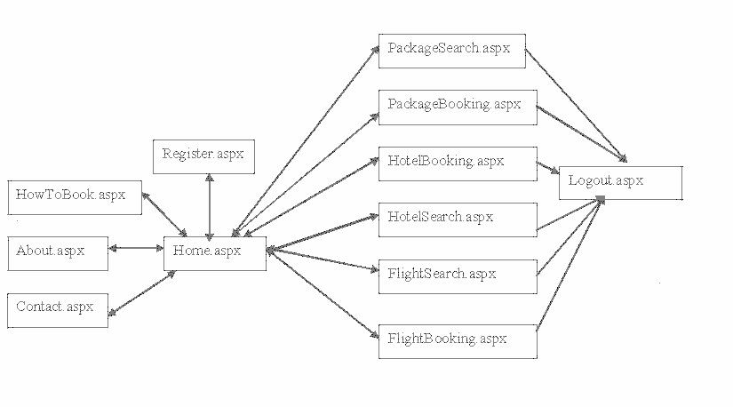

The home page of the Airline Reservation System has the login id and the password field for the user to login. So the home page can also be used as the login page for the customer.

4. BUSINESS LOGIC TIER

The Business Logic Tier is the middle tier of the three-tier architecture. The business logic for the Airline Reservation System would be present here. In the case of my project, the C# classes would be performing the duty of the business logic. This is the layer which is responsible for the information exchange between the user interface and the database.

The Airline Reservation system mainly consists of the Users, which can be further classified into the customer and administrator of the Airline Reservation System website. The class diagram for the Airline Reservation System would be as follows:

4.1 CLASS DIAGRAM

Figure 6 - class diagram
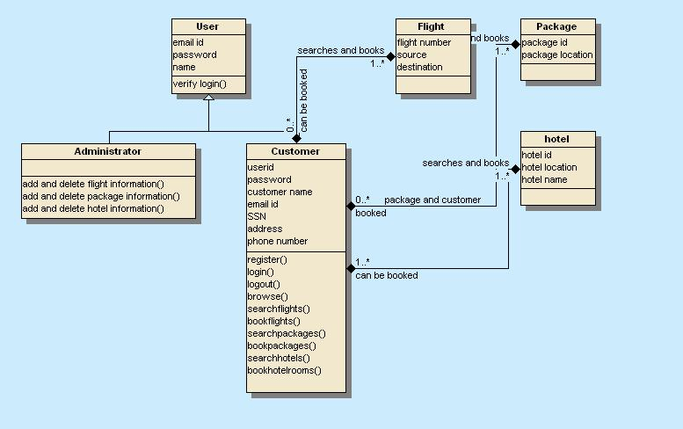

4.2 SEQUENCE DIAGRAM

The sequence diagram for the Customer of the Airline Reservation System would be as follows:

Figure 7 - sequence diagram for customer
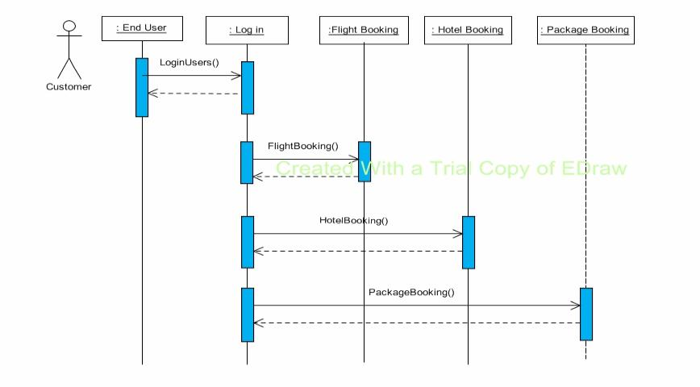

5. DATABASE TIER

The database tier is the final and last tier of the three-tier architecture. All the data related to the Airline Reservation System project is stored and retrieved from here. For this project I have used the Microsoft SQL server to create the database. To be specific, Microsoft SQL server 2000 is being used. It is very easy to work with and makes creation and maintaining of tables very easy.

CHAPTER 3 - COMPONENT DESIGN

1. INTRODUCTION AND PURPOSE

The main purpose of the Component Design document is to provide and explain the component design for the Airline Reservation System project in detail.

2. CLASS DIAGRAM

The class diagram of the Airline Reservation System project would be as follows:

Figure 8 - class diagram
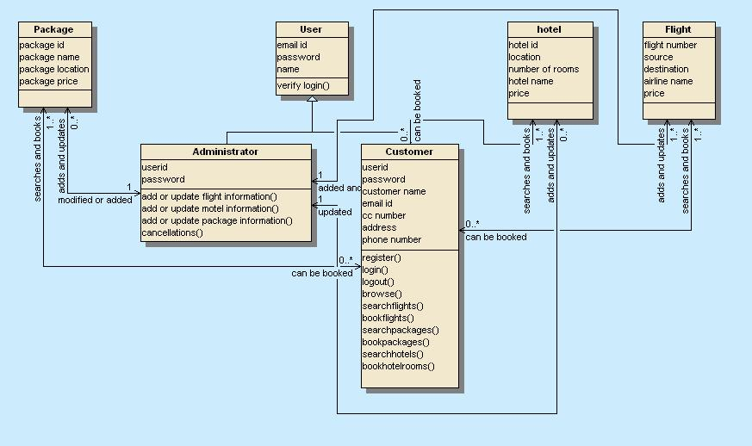

2.1 CLASS DESCRIPTIONS

2.1.1 USER
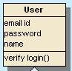

Figure 9 - user class

The user class is responsible for handling all the user functions. This user class is the super class or the base class for two types of users namely the customer and the administrator. The user logging into the system will be mainly verified for their username and password., which is the email id for the customer and a username for the administrator.

2.1.2 ADMINISTRATOR
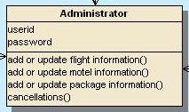

Figure 10 - administrator class

The administrator class is the sub class of the user class. This class is mainly depicted here to define all the attributes and functions carried out by the administrator of the Airline Reservation System website. The attributes for the administrator of the Airline Reservation System website are the userid and password, which the administrator uses to log on to the Airline Reservation system website. The administrator would be able to perform the tasks of adding or updating the information for flights, motels and packages etc.

2.1.3 CUSTOMER
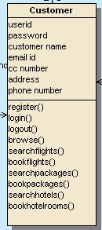

Figure 11- customer class

The customer class has been depicted here as it is a sub class for the super class user of the Airline Reservation System project. The attributes for the customer would be the userid, password, customer name, email id, credit card number, address, phone number. The functions that the customer of the website would be able to perform are :

Register() – the customer would be able to register onto the system

Login() - the customer can login with the email id and password

Logout() – the customer would be able to logout of the system Browse () – the customer can browse through the website

Searchflights() and bookflights() – the customer would be able to search and book the flights available on the website.

Searchpackages() and bookpackages() - the customer would be able to search and book packages available on the website

Searchhotels() and bookhotels() - the customer would be able to search and book for the hotels available on the website

2.1.4 PACKAGE
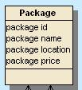

Figure 12 - package class

The class package is depicted in the class diagram to represent the set of packages present in the application. The customer can book packages using the PackageSearch page. Package generally has the following attributes:

Package id – a unique id given to a package

Package name – the name of the package

Package location - the location of the package…it indicates the place where the package is available

Package price – the price of the package

2.1.5 FLIGHT
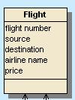

Figure 13 - flight class

The class flight is depicted in the class diagram to represent the set of flights present in the application. The customer can book packages using the FlightSearch page. A flight present in the airline reservation system, generally has the following attributes: Flight number - A unique number is given to the flight

airline name – the name of the airline that the flight belongs to source – the place where the flight has as its beginning point destination – the place where the flight has as its end point price – the price of the airline ticket of a particular flight

2.1.6 HOTEL
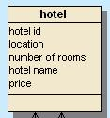

Figure 14 - hotel class

The class hotel is depicted in the class diagram to represent the set of hotels present in the application. The customer can book hotels using the HotelSearch and HotelBooking page. A Hotel available in the Airline Reservation System application generally has the following attributes:

hotel id – a unique id given to a hotel

hotel name – the name of the hotel

location - the location of the hotel

number of rooms – the number of rooms available at each hotel price – the price of each room in a hotel

REFERENCES

The following references have been used by me, during all the phases of the MSE project:

- http://www.w3schools.com/

- www.msdn.microsoft.com

- Apache J Meter - http://jakarta.apache.org/jmeter/

- http://mse.cis.ksu.edu/ - For MSE Project Portfolio.

- IEEE Recommended Practice for Software Requirements Specifications - IEEE Std 830-1998

6.Django project
- http://www.devarticles.com/c/b/SQL-Server/ - SQL server 2000 help

- http://www.sitepoint.com/article/sql-server-2000-database - SQL server 2000 help

- SQL Server 2000 download - http://www.microsoft.com/downloads/

- http://www.c-sharpcorner.com/

- IEEE Standard for Software Test Documentation IEEE 829-1998

- http://www.mhhe.com/engcs/compsci/pressman/information/olc/COCOMO.html

- Smart Draw software for the Gantt Chart

- Wikipedia

